Audience Analysis
Alex Hoare

Lesson topic: Understanding Abstract Art

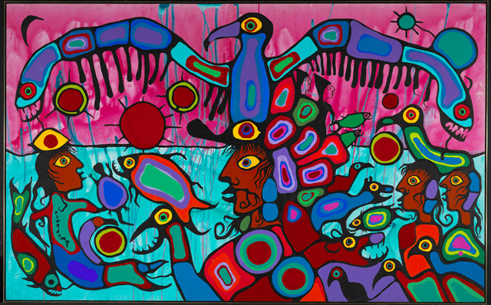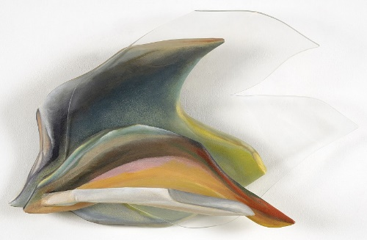

Lesson description:
This 1-hour lesson will teach a group of eighteen young teens (age 15) how to interpret, understand, and describe abstract art. The lesson will form part of a trip undertaken by a Grade 10 Arts and Culture class from a high school in Toronto to the National Gallery of Canada in Ottawa, in order to satisfy a requirement of the Ontario Ministry of Education’s arts curriculum.
The lesson will be delivered by a gallery curator. It will have some structure but will primarily follow a question-and-answer delivery format and consist, in part, of a series of short interactive activities that give students the opportunity to apply and demonstrate their learning. As part of the lesson, students will engage closely with and compare three works of art in the National Gallery’s Contemporary Art and Indigenous Art collections.
The selection of works of art for discussion will embrace (as much as is possible within the boundaries of a short lesson) different media and artistic identities. Students will learn about abstract art by participating in—and also learning, in the process—various key practices involved in the visual and contextual analysis of art.
The three works of art that students will work with in the National Gallery are: Barnett Newman’s Voice of Fire (1967); Norval (Copper Thunderbird) Morrisseau’s Artist and Shaman between Two Worlds (1980); and Lilian Thomas Burwell’s Dolphin Spirit (2006) (pictured above, from left to right). The works of art selected treat relatively neutral, recognizable, or relatable subject matter and do not push the boundaries of interpretation into too complex or controversial a territory for a young audience, yet will still prompt questions and require them to think a little.
(For the purpose of this lesson I have taken some liberties by including Burwell’s sculpture, which is not part of the National Gallery’s collection but represents the work of an important, living, Black female abstract sculptor. The Gallery’s collection of abstract art is dominated by the work of dead white men—as is the highly influential mid-century category of Abstract Expressionism, more generally—but I want my young and diverse audience to learn about the much larger cultural and temporal scope of artistic engagements with abstraction.)

Tentative learning objectives:
- to be able to describe the key visual differences and connections between figurative/representational art and abstract art

- to be able to define what “abstract” means in reference to art: the different ways in which the term “abstract” has been used historically in reference to art; the varying ways in which individual artists or distinct cultures define, understand, or use abstraction; how art of this kind first originated; why artists create it; and some of the ideas it expresses

- to be able to use key terms and vocabulary relevant to abstract art (including the names of a few important artists and relevant contextual or historical events)

- to be able to apply this knowledge elsewhere—both to other examples of abstract art in the National Gallery and museums like it, and to other forms of abstract artistic expression that they might encounter in their daily lives (in social media, gaming, films, etc.)

Primary audience:
A group of eighteen students (age 15; Grade 10) from diverse backgrounds, of mixed gender and ethnicity, all from Toronto and all enrolled in the same high school Arts and Culture class.

Secondary audience:
The school teacher responsible for the class and one teaching assistant will also be in attendance, to help corral the group and keep them focused on the lesson. The teacher and teaching assistant will also be monitoring how the lesson goes, with an eye to future visits (they will be keeping track of what goes well and where there might be room for improvement), and paying attention to the content covered so that they can build on this during subsequent in-class lessons. They may also have a personal interest in the subject matter. A Gallery docent and security guard will also be present, but will not be directly involved in delivering the lesson.

Learner impairments, physical needs, and possible triggers:
Two students have a low-level learning impediment (ADHD) that has been identified to the lesson instructor; they require more time to process information and will benefit from intermittent reinforcement and repetition to help stay on task, and from a greater variety of learning activities to help provide context for complex ideas.
Some students may find the works of art provocative, challenging, or silly, and the objects they encounter will likely prompt a range of unpredictable reactions on students’ part. Works of art have been carefully chosen for the audience in question and their level of maturity and experience, while not sacrificing the importance of learning about—and understanding the appropriate way to engage with and respond to—provocation as a key aspect of contemporary art. This appropriate behavioural response will be a secondary, undeclared learning objective. Students will be primed at the start of the lesson (in terms that they understand) to behave with respect and objectivity.
There are no students in the class with physical accessibility needs, but the lesson space and Gallery have been confirmed as fully accessible should any un-anticipated needs arise prior to their arrival.

Level and types of learner knowledge:
The students have already been introduced to the subject in school, and have varying degrees of knowledge about or interest in art. They will already have learned some basic art-historical concepts and vocabulary.
The lesson will be delivered in English. All students speak, read, and understand English, but some may struggle a little with new terms or vocabulary, and will benefit from repetition and opportunities to use and apply those words to additional contexts.

Level and nature of learner participation:
Students are all in attendance because they are required to be. Some will be genuinely engaged and want to participate, while others will be less interested and their attention may wander a little.

Timing, space, teaching materials, and practical requirements:
The lesson will be delivered over the course of 1 hour in one of the gallery spaces of the Contemporary Art collection that has been reserved specifically for the group for that time-frame. The lesson’s duration has been set at 1 hour, as this is the maximum amount of time that an audience of this kind will be able to remain focused, engaged, and participatory. All three works of art that form the focus of the lesson will be in this space. No other public visitors to the Gallery will be allowed into the space during the lesson.
Some information will be taught using a series of slides (with short texts and images), projected onto a blank wall in the gallery space, to help supply learners with additional contextual imagery and information, and to demonstrate the spelling of key terms. Students will be provided with chairs and clipboards. Students will also be given pencils and a printed handout that incorporates supporting materials (including all of the information given to them in the slides) and some blank pages, to be used during the lesson’s activities. They will not be permitted to use their phones or other electronic devices (these will be placed in a tray in the room) until the end of the lesson, when they will retrieve them for use in the final lesson activity. (This is a post-pandemic lesson, so students will be free to move about and come into contact with one another.)
The writing style used in the lesson’s materials and delivery will consist of a mix of formal and informal approaches, with simple phrasing that breaks down complex ideas and focuses on relatability (i.e., linking ideas and terminology to contexts that may be more familiar to the students).
A Gallery docent will be on hand to help with any technical difficulties.

Reason for the lesson, and audience needs:
The lesson is intended to satisfy one of the requirements of the Ontario Ministry of Education’s arts curriculum (a hands-on, experiential learning exercise), but is also an important undertaking for the educational programming department at the National Gallery of Canada, which is eager to find new and creative ways to engage diverse audiences with their collections.
At this stage of study (Grade 10), the arts curriculum requires that students be given the opportunity to “gain insights into the world around them [and] into the human condition,” and be able to “identify common values, both aesthetic and human, in various works of art.” The goal is for students to “increase their understanding of others and learn that the arts can have a civilizing influence on society. Through studying works of art from various cultures, students deepen their appreciation of diverse perspectives and develop the ability to approach others with openness and flexibility.” One of the overarching learning objectives of the lesson is for students to be able to exercise their aesthetic judgment, by taking what they know and applying it to a new context. The specific subject to be covered also aims to teach them about cultural differences and connections, through the lens of art history. The lesson also responds to one of the requirements stipulated in the curriculum’s outline of teachers’ roles and responsibilities within the arts program: to arrange visits to art galleries, museums, and other cultural institutions in order to “provide rich environments for field trips and for exploration of the local community and its resources.”
The subject of the lesson—abstract art produced by a diverse group of artists—was jointly devised by the curator and the teacher, and is informed by knowledge of what this age group finds interesting, relatable, and comprehensible.

Information about the Ontario Ministry of Education’s arts curriculum is taken from The Ontario Curriculum, Grades 9 and 10: The Arts (2010), pp. 3-4, 7.

